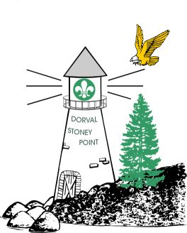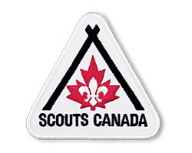

**Dorval –Stoney Point**

Spring Cub Camp 2025

Camp Kinkora

May 30 to June 1

Dear Parents and Cubs

It's Spring Camp time again and as in past years the Cub Leaders have planned an exciting, fun-filled weekend at Camp Kinkora. Applications and money to be returned to your Akela before 16th of April.

Transportation to Camp is the responsibility of the parent unless your pack is making special arrangements.

We suggest car-pooling if possible to cut down on the number of vehicles entering and leaving camp. If you

are able to take an extra cub or two, please indicate this on your application form.

LOOKING FORWARD TO SEEING YOU AT CAMP.

~~~~~~~~~~~~~~~~~~~~~~~~~~~~~~~~~~~~~~~~~~~~~~~~~~~~~~~~~~~~~~~~~~~~~~

KIT LIST FOR CAMP

|  |  |  |  |
| --- | --- | --- | --- |
| Complete Uniform | Medicare Card | Running Shoes | T-shirts (2) |
| Long sleeved shirt | Warm Sweater | Socks (4 Pairs) | Pants (2) |
| Sleeping Bag  (In Waterproof bag) | Laundry Bag  (pillow case) | Flashlight  (New Batteries) | Change of  Underwear |
| Back Pack  (No sport bags) | Sun Hat (important) | Medicine (if any) | Bug Repellent  (not aerosol) |
| Rubber Boots  (write name inside) | Mosquito Hat Dollar Store (bring extra) | Stuffed Animal | Raincoat |
| Small Pillow | Toque & Mitts | Warm Jacket | Sun-block SPF 30+ |
| Toothbrush & paste | Towel | Face Cloth | Soap |
| Pyjamas | Water bottle | Swimsuit |  |

No Sandals or Flip flops

**NOTE:** Medicare cards and medications (not EpiPen or Asthma medications) to be given to your Akela.

Cubs must travel in uniform. Light clothing deters bugs. Put cub’s name on everything.

Eat before leaving on Friday as there will only be a snack (mug-up) at bedtime.

Jump Scouts : Bathing suit, day pack , Super Soakers, (not expensive), dark T-Shirt

**Do not bring** Candy, food, soft drinks, knives, radios or electronic games. These items will be

confiscated by leaders.

**Theme:** Harry Potter